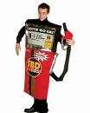

1. Students may dress up for Halloween only if they are wearing an actual full COSTUME – not just a wig or a shirt. All costumes must adhere to the standard dress code policy in the student planner (pg. 14).
2. Students who are not in costumes must be in proper school uniforms. This is NOT a free dress day.
3. Costumes cannot depict ordinary, everyday people (surfer, swimmer, skateboarder, basketball player, etc.) Everyday clothing will NOT be acceptable unless it has been significantly altered to be a valid costume.
4. No pajamas and no offensive or revealing outfits (KKK robes, belly dancer, etc.) Gothic attire and make-up are not acceptable costumes.
5. Masks or face coverings cannot be worn in classrooms or around campus. These MAY be used if you are entering the lunch-time Costume Contest, but only for that time.
6. Make-up or hair spray/dye must be applied AT HOME with parent permission. These products are NOT allowed on campus.
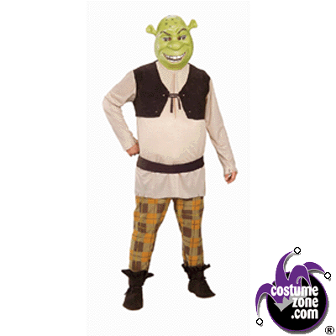
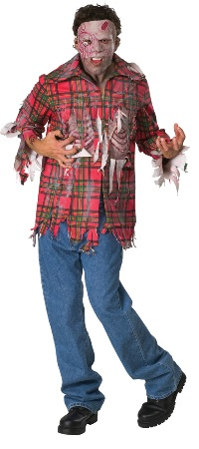
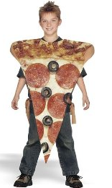
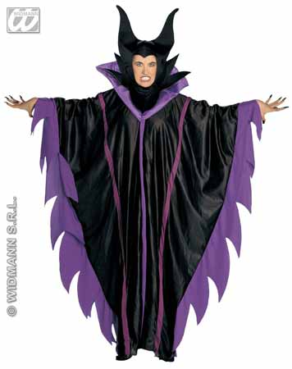
7. No weapons (even fake ones), no pointed or metal accessories, no contraband items.
Contestants for the Costume Contest should report to the café stage within the first 10 minutes of the lunch period. Only contestants in full costume may enter. Treats for all participants! Prizes for winners!

